**Analysis documentation of Bellabeat**

* Initially uploaded all the .csv files which is need for analysis
* Verified the structure remains the same using ‘head’ command
* Next verify the number of records and ensure that there is no duplicate record in the tables.
* The table daily_sleep_avg_idletime was a pivoted we remove the default null values and added the column name
* Created a final merged table with uniform column names









**Findings**

Now we classify users based on the fact how active they are during a day . Here steps taken by the user is used as measuring factor for classifying users.

**Table used** : merged_daily_records_1 which consists of record of 24 users

|  |  |
| --- | --- |
| Steps | Type |
| Less than 3000 | Less_active |
| 3000 to less than or equal to 5999 | fairly_active |
| 6000 to less than or equal to 9999 | Active |
| More than or equal to 10000 | very_active |

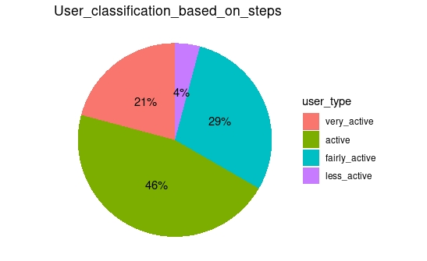

**Initial correlation between distance and sleep**:

**Table used :** merged_daily_records_1 which consists of record of 24 users.

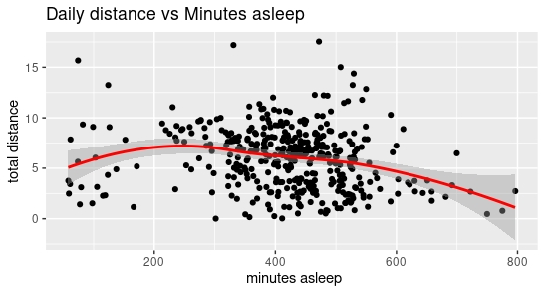

From the graph, we can conclude that there is no relationship between a user sleeps vs the distance he travels per day.

**Average sleep per day**

**Table used:** merged_daily_records_1 which consists of record of 24 users.

Let us check whether the users are sleeping ample time per day i.e. 8 hrs/day

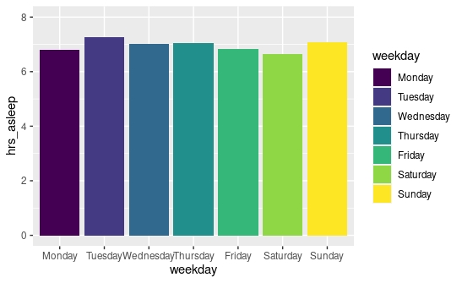

It is clearly evident that the users aren’t sleeping per the normal recommended standards.

**Average calories burnt per day :**

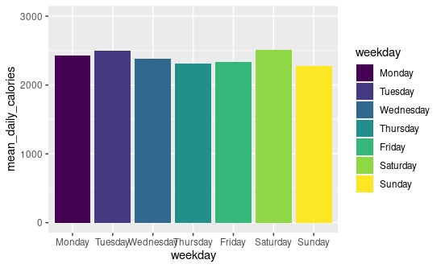

It is clear that the Bellabeat users are almost uniformly active among all days of the week .

**Classification of users based on number of days they wore the Bellabeat tracker**

**Table used** : daily_activity.xlxs , **Platform used**: Google sheet

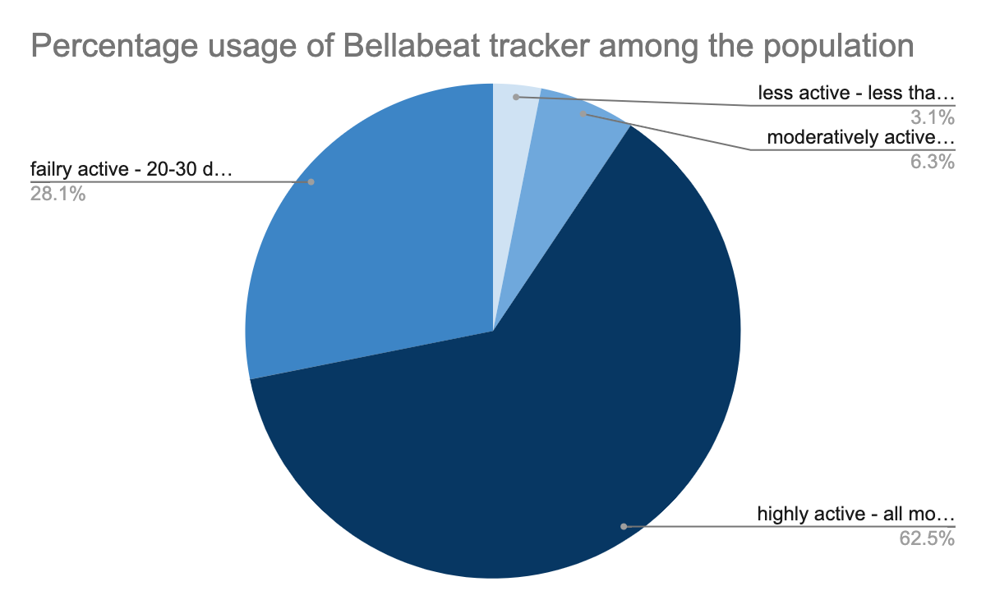

From the graph it is clear that approx. 63% percent of the users uses the tracker all month while 90% of the sample uses the tracker for 20 days to all month.

**Classification of user on BMI**

**Table used**: weightLogInfo_merged.csv

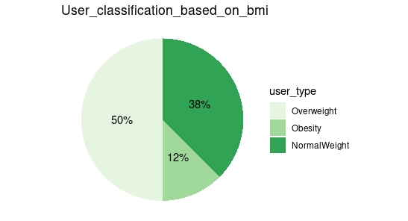

Half of the population is overweight i.e. their BMI is between 25.1 to 29.5. Scale is taken from <https://www.nhlbi.nih.gov/health/educational/lose_wt/BMI/bmicalc.htm>

The shortcoming of this finding is sample of this table is small ie only 8 users data have been analysed for a month , hence this finding needs to be test for a larger population for validation.

**Suggestions to the Bellabeat marketing team based on the analysis:**

* It is clearly evident that the users doesn’t sleep for recommended hours , hence we can send notifications to the users regarding their sleep starting from 10 pm for office goers and 9 pm for students.
* From the given dataset we observe that 50% of the users who opted for weight monitoring is in “overweight” category and 12% of users are “Obese” , hence we can provide various workout videos and dietary plans in our Bellabeat app . The workout videos can be free in the App whereas the dietary plan from top dieticians should be added in Bellabeat membership so that it could also be revenue generating for the company.
* Bellabeat membership should be given free for a month to all user on a trial basis so that people once people uses the premium feature and understand its benefit, the chances of them continuing it becomes higher and also yields revenue for the firm.
* Bellabeat is known high-tech manufacturer of health-focused products for women but it doesn’t has a female menstrual cycle tracker. Introducing a cycle tracker will significantly improve their sales.
* Introducing reward point program where users can set their monthly goal based on their preferences and as give Bellabeat membership as the reward for a month as one of the rewards. And allow users can sync their social media where they can post their achievement by that means users also get their internal satisfaction and our product reach will also be wider.
* Given the fact that bellabeat wants to become a major player in global smart device market, bellabeat should also focus on which type of product sells the most among their given Bellabeat LEAF variant and try to focus on it more as their core product whereas keeping the other products as a cover to the competition.
* Now for the marketing side, Bellabeat should focus less on Print-media and use that revenue on setting small spot in malls so that users has some in-hand experience rather seeing ads in social media. And Bellabeat should introduce a dedicated customer service line so that any queries has been dealt immediately in telephone regarding product usage. And also try to few introduce physical stores in malls in tier 1 cities and in main streets of tier 2 cities (given the fact Bellabeat wants to expand their market) at least for the initial phase.

**Limitation & Scope of Improvement of this analysis:**

* The population used for this analysis is small (33 users records) , thus needed to test and see against a large population if this produce same results.
* The weightLogInfo_merged table has only records of 8 distinct user records which we used for classification of people using BMI.
* Though there were 18 tables, apart from the tables we used for analysis, rest of the table records were either summarised in merged table or its minimal to consider for any analysis.



The above table depict the datasets limited records issue.

**Additional Inferences:**

* Generated user type on healthy or obese based on sedentary minutes – sleep minutes of the records and plotted a pie chart after removing the outliers. The results shows that nearly 38 % of the records are of normal weight i.e. healthy, whereas ~52% is Overweight and ~10% is obese.

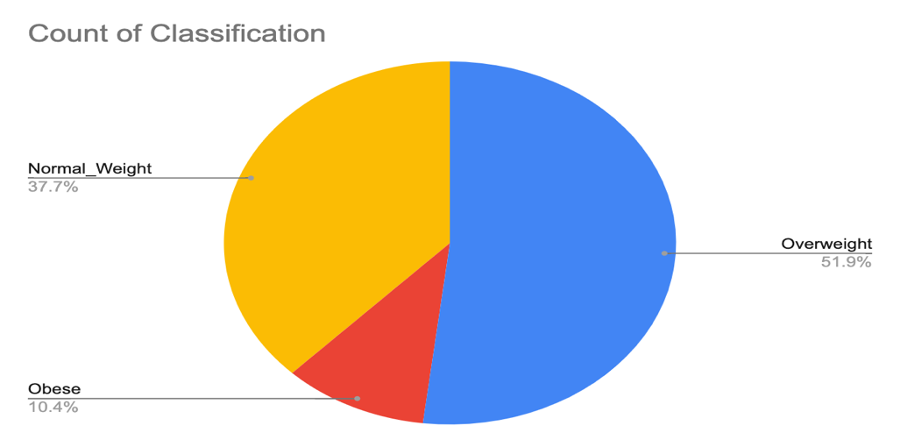

|  |  |
| --- | --- |
| **Total Sedentary Minutes**(Non Sleeping Time) | **Type** |
| Less than 270 | Normal Weight |
| 270 to less than 570 | Overweight |
| Greater than 570 | Obese |

* **Correlation between Daily Steps vs Calories:**

Data have been normalised and taken with 3 SD so that outliers are removed. Correlation coefficient for this is 0.57



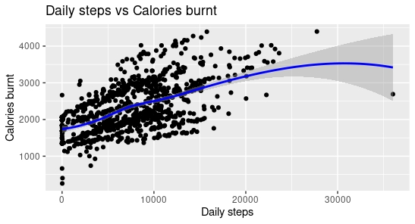

From the graph we can clearly see an positive linear correlation between the amount of calories burnt vs number of steps , the users walk per day.

* **Testing the impact of sedentary minutes on sleep of the users:**

Sedentary minutes and sleep data have been normalised for the user records and included data with 3SD after filtering the outliers.



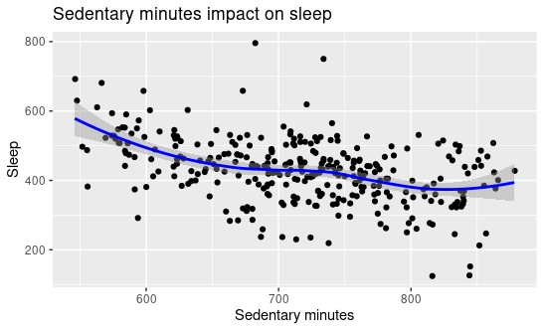

The negative correlation indicates that higher the person has a sedentary lifestyle the less that person sleep.